**NAME:** SARIKA M

**SYNTAX AND BASIC COMMANDS IN JAVA**

* **CASE SENSITIVITY:**

It is case sensitive means hello and Hello has different meanings.

* **CLASS NAME:**
* Class name should begin with **upper case** followed by **lower case** .
* If it is combination of words ,each word’s starting letter should be  **upper case** .
* Example : PrimeNumber,OddEvenNumber
* **METHOD NAME:**
* In java anything and everything is object
* Starting letter should be **lower case**
* If its combination of words , Starting letter should be **lower case**

next word’s starting letter should be  **upper case** .

* Example : myMethod(Name)
* **PROGRAM NAME:**
* Name of the program file should **exactly match**  the  **class name.**
* Keywords **cannot**  be used as  **Identifier**  as they are predefined.
* Keywords are – “abstract, assert, Boolean, break, byte, case, catch, char, class, const , continue, default, do, double, else, enum, extends , final , finally , float , for , goto , if , implements , import , package , private , protected ,instance of , int , interface , long , native , new ,public , return , short , strictfp ,super ,switch , synchronized ,this , throw , throws , transient , try , void , volatile , while “
* **Comments**
* Single line command- //comment
* Multi line command -/*

*

*

*/

* **Printing hello world**

**public** **class** Hello {

**public** **static** **void** main(String[] args) {

System.***out***.println("hello world");

}

}

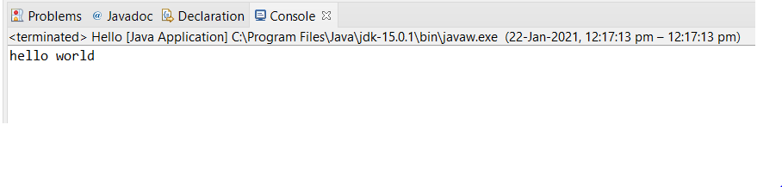

* **Getting input from the user**

**import** java.util.Scanner;

**public** **class** Input {

**public** **static** **void** main(String[] args) {

Scanner scan=**new** Scanner(System.***in***);

System.***out***.println("enter value");

**int** user_input=scan.nextInt();

System.***out***.println("value is");

System.***out***.print(user_input);

//Scanner scan1=new Scanner(System.in);

System.***out***.println("enter value");

**double** user_input1=scan.nextDouble();

System.***out***.println("value is");

System.***out***.print(user_input1);

Scanner scan2=**new** Scanner(System.***in***);

System.***out***.println("enter string");

String user_input2=scan2.nextLine();

System.***out***.println("string is");

System.***out***.print(user_input2);

}

}

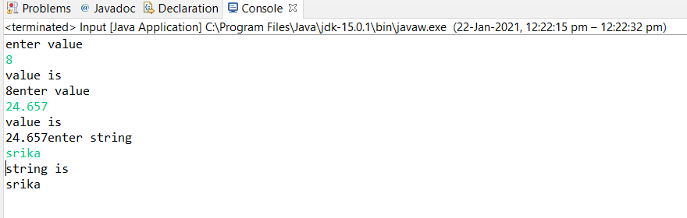

* **Math and arthimetic operators**

**public** **class** Maths {

**public** **static** **void** main(String[] args) {

**int** x,y;

x=10;

y=10;

//answer=x % y;

System.***out***.println("answer ="+ (x+y));

**double** a,b,answer1;

a=20;

b=30;

answer1=a / b;

System.***out***.println("answer1 ="+ answer1);

}

}

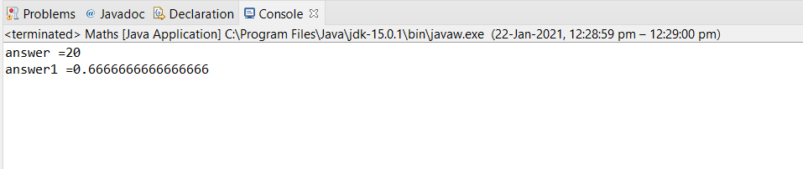

* **Increment operator and assignment operator**

**public** **class** Incrementor {

**public** **static** **void** main(String[] args) {

**int** x=10;

System.***out***.println(x++);

System.***out***.println(x);

System.***out***.println(++x);

}

}

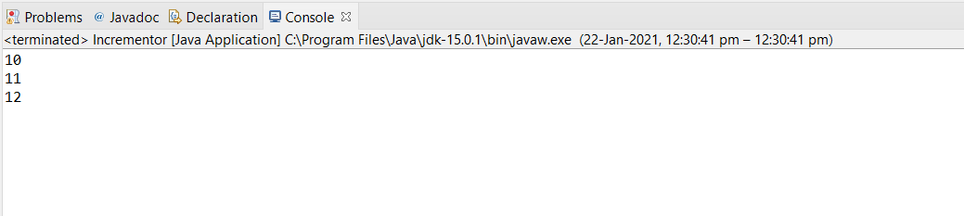

**public** **class** Assignment {

**public** **static** **void** main(String[] args) {

**int** x=10;

x+=5;

System.***out***.println(x);

}

}

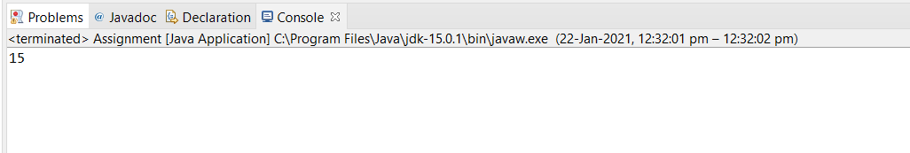

* **Relational operator**

**public** **class** Relational {

**public** **static** **void** main(String[] args) {

**int** a=10;

**int** b=20;

System.***out***.println("a==b="+(a==b));

System.***out***.println("a!=b="+(a!=b));

System.***out***.println("a>=b="+(a>=b));

System.***out***.println("b<=a="+(b<=a));

System.***out***.println("a>b="+(a>b));

System.***out***.println("a < b="+(a<b));

}

}

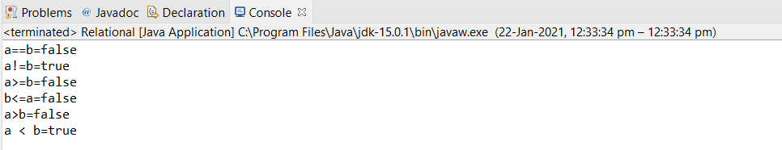

* **Bitwise operator**

**public** **class** Bitwise {

**public** **static** **void** main(String[] args) {

**int** a = 10;

**int** b = 20;

**int** c;

c = a & b;

System.***out***.println("a & b="+c);

c=a|b;

System.***out***.println("a | b="+c);

c=a^b;

System.***out***.println("a^b="+c);

c= ~a ;

System.***out***.println("a~b="+c);

c= a>>2;

System.***out***.println("a>>2="+c);

c=a<<2;

System.***out***.println("a<<2="+c);

c=a>>>2;

System.***out***.println("a>>>2="+c);

}

}

}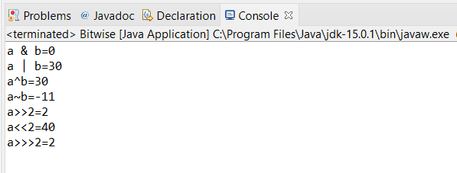

* **Logical operator**

**public** **class** Logical {

**public** **static** **void** main(String[] args) {

**boolean** a=**true**;

**boolean** b=**false**;

System.***out***.println("a&&b="+(a&&b));

System.***out***.println("a||b="+(a||b));

System.***out***.println("!(a&&b)="+!(a&&b));

}

}

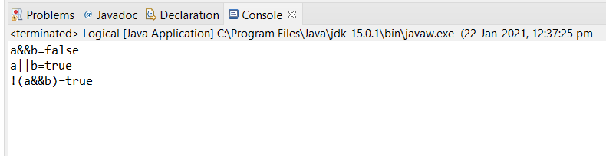

* **Conditional operator**

**public** **class** Conditional {

**public** **static** **void** main(String[] args) {

**int** a=10,b=20,c;

c=(a==b)?20:30;

System.***out***.println("value of b ="+c);

c=(a==10)?20:30;

System.***out***.println("value of b ="+c);

}

}

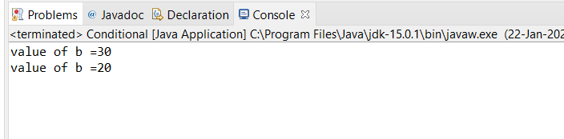

* **If-else statement**

**public** **class** Ifnelse {

**public** **static** **void** main(String[] args) {

**int** x=10;

**if**(x<20) {

System.***out***.println("if");

}

**else** {

System.***out***.println("else");

}

}

}

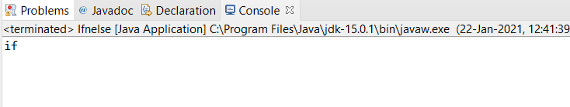

* **If-else-if statement**

**public** **class** Ifelseif {

**public** **static** **void** main(String[] args) {

**int** x=30;

**if**(x==10) {

System.***out***.println("x==10");

}

**else** **if**(x==20){

System.***out***.println("x==20");

}

**else** {

System.***out***.println("x==30");

}

}

}

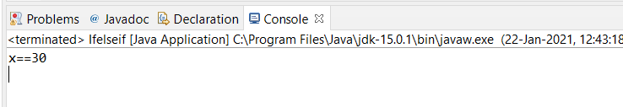

* **Nested if statement**

**public** **class** Nest {

**public** **static** **void** main(String[] args) {

**int** x=30;

**int** y=20;

**if**(x==20) {

**if**(y==30) {

System.***out***.println("yes");

}

**else** {

System.***out***.println("y is wrong");

}

}

**else** {

System.***out***.println("x ix wrong");

}

}

}

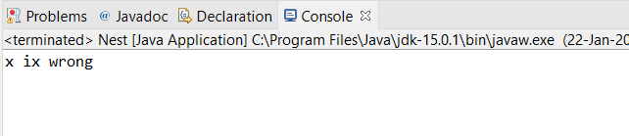

* **Switch statement**

**import** java.util.Scanner;

**public** **class** SwitchStmt {

**public** **static** **void** main(String[] args) {

**int** choice;

System.***out***.println("pick your choice:\n"

+ "1.hi\t 2.hey\t 3.hello\t");

Scanner s=**new** Scanner(System.***in***);

choice=s.nextInt();

**switch**(choice) {

**case** 1:System.***out***.println("you said hi");

**break**;

**case** 2:System.***out***.println("you said hey");

**break**;

**case** 3:System.***out***.println("you said hello");

**break**;

**default**:System.***out***.println("invalid choice!");

}

}

}

